EXPLORATORY DATA ANALYSIS
USING SQL TO CLEAN, TRANSFORM AND ANALYSE
This project focuses on a company dealing in classic, vintage, and collector automobiles. The dataset, MintClassics, contains information on sales, products, services, and operational processes.
After uploading the MintClassics database file into MySQL Workbench, the data was further explored and exported to Excel to identify and extract the relevant information from the dataset. The selected data was then imported into a CSV file for further processing.
This section includes a screenshot of the SQL command used to extract the required data
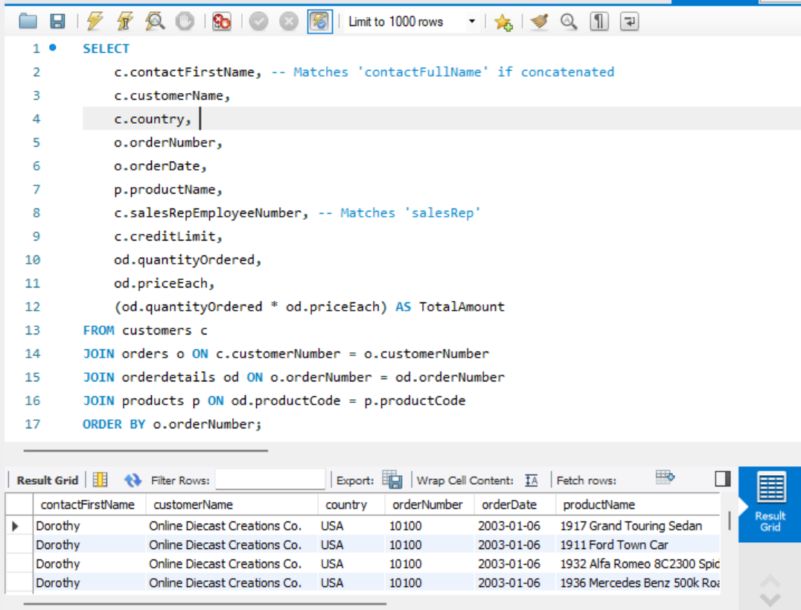
The screenshot shows the CSV file in Excel, where initial data cleaning was performed to identify mismatches and remove duplicates. A MySQL database was then created, and the cleaned data was imported into MySQL Workbench. Although the dataset was already cleaned in Excel, SQL was still used for further data cleaning and transformation as part of the ETL (Extract, Transform, Load) process before analysis.
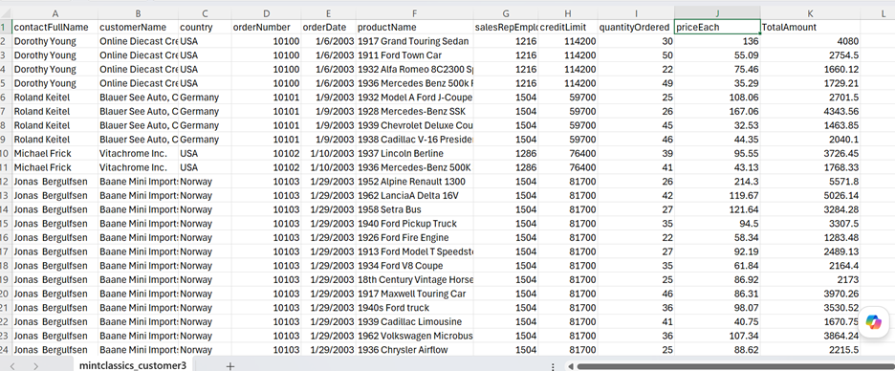
In these Project, SQL is used to transform "raw" transactional data into a "decision-ready" format. This process is often referred to as ETL (Extract, Transform, Load), ensures that the analysis is based on accurate, standardized, and meaningful information.
Here are the primary types of data cleaning and transformation tasks typically performed using SQL in this project:
Typical Transformation Workflow for MintClassics:

k Type used | SQL Operation Command Used | Purpose
Cleaning | WHERE, COALESCE, UPPER | Removes noise and standardizes inputs.
Transformation | SUM, AVG, CASE | Creates KPIs like "Revenue" or "Inventory Turnover."
Structuring | JOIN, UNION, WITH (CTEs) | Combines disparate tables into one cohesive report.

Example SQL does not understand this date format 1/6/2003 therefore transformed into Year- Month-Date
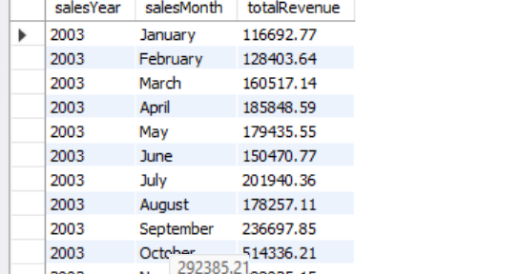

ANALYSIS 1
Using these SQL queries with SUM, total Products ordered were calculated
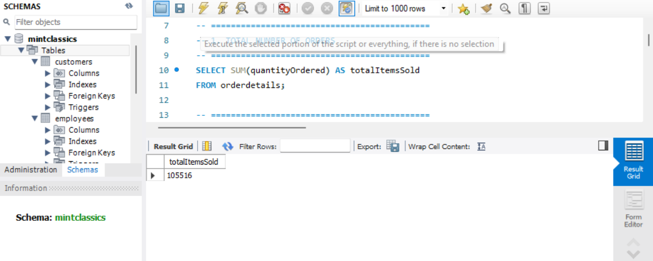
ANALYSIS 2:
Calculate the total revenue using an SQL query.
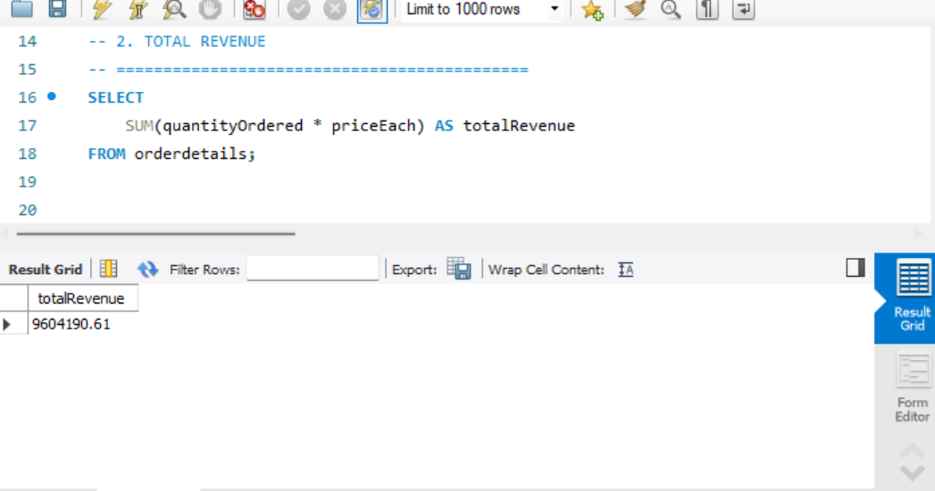

ANALYSIS 3
With SQL queries using LEFT JOIN, GROUPBY, Countries with highest Sales limited to 10.
This analysis is based on aggregated sales data, ensuring accurate comparison across countries.”
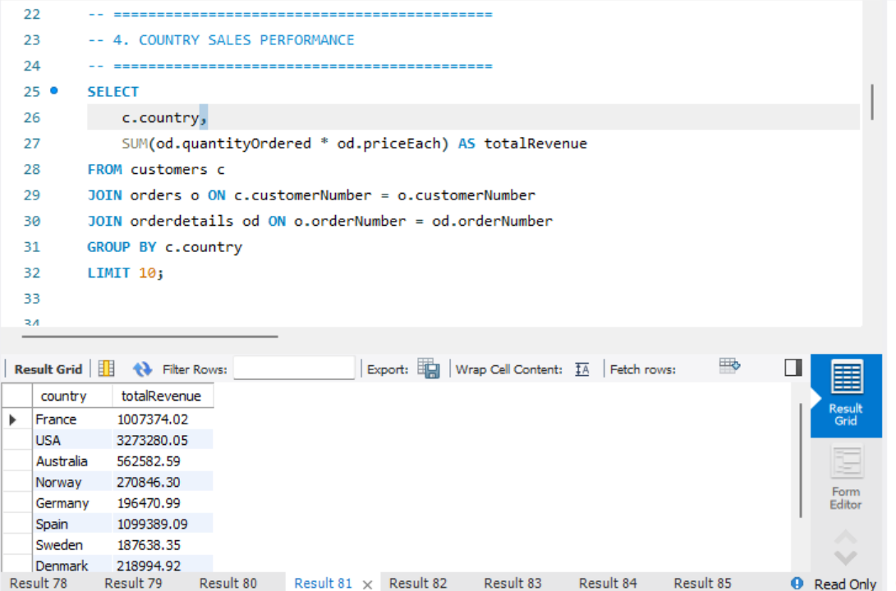

ANALYSIS 4
Understanding Products quantity in Stock across warehouse
The SQL commands used are structuring, JOIN, FROM, and ORDERBY.
This insight supports better demand planning, inventory balancing, and cost control strategies especially in the case of warehouse utilization
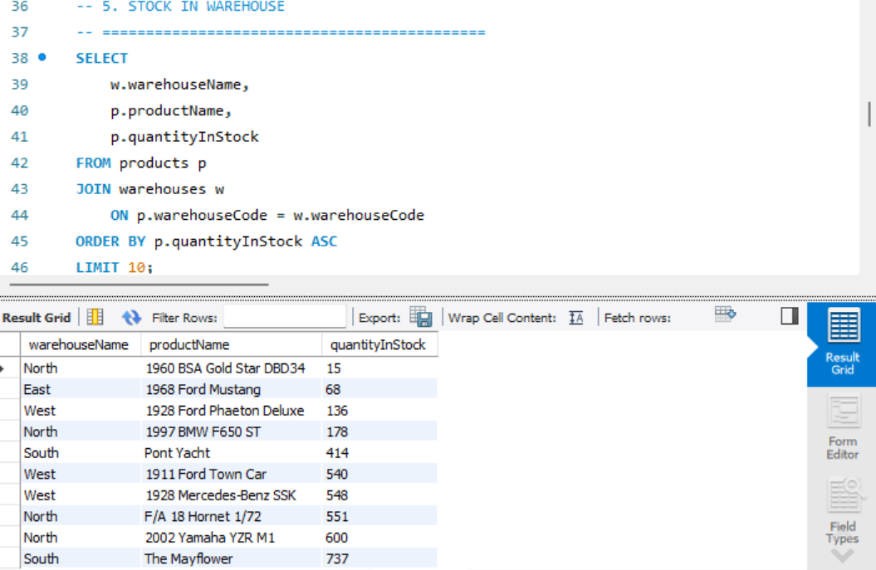

Analysis 5: Sales Representative Performance
Using SQL, I analyzed sales data to identify the top five sales representatives based on total revenue generated. This insight enables stakeholders to evaluate individual performance, recognize high achievers, and design incentive programs that drive motivation and productivity. Additionally, it helps identify performance gaps and opportunities for training and development.

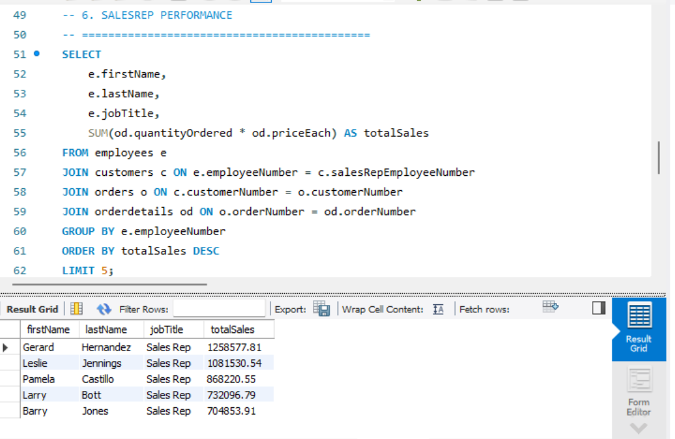

ANALYSIS 6: PRODUCT HIGHEST DEMAND
Using SQL queries such as SUM, JOIN, GROUP BY, and ORDER BY, I analyzed the seven most in-demand products based on revenue. This analysis provides stakeholders with clear insights into the best-performing products as well as those with lower demand, enabling the team to make more informed strategic decisions aimed at improving underperforming products.
naldi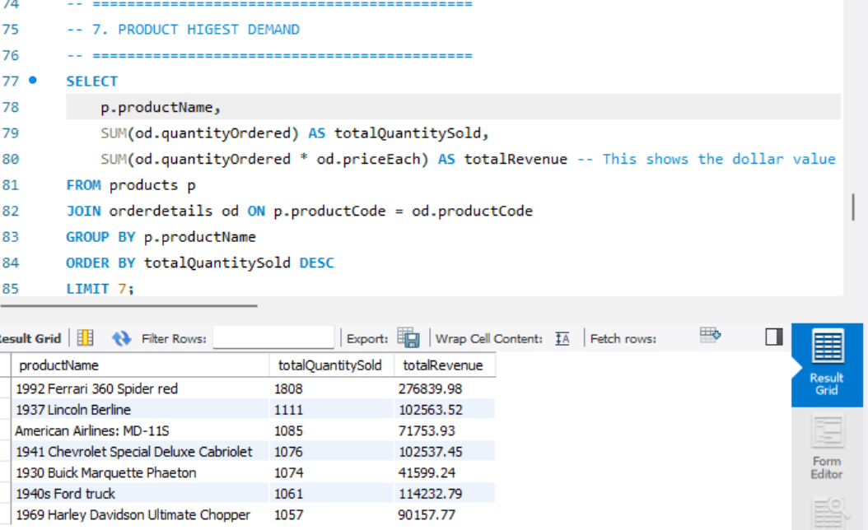

ANALYSIS 7: SALES TREND
SQL (Structured Query Language) was used to efficiently extract and analyze sales data from the Mint Classics dataset for the period 2003 to 2005. By aggregating sales on a yearly basis, this analysis provides a clear view of revenue trends over time, enabling stakeholders to assess business performance and identify growth or decline patterns.
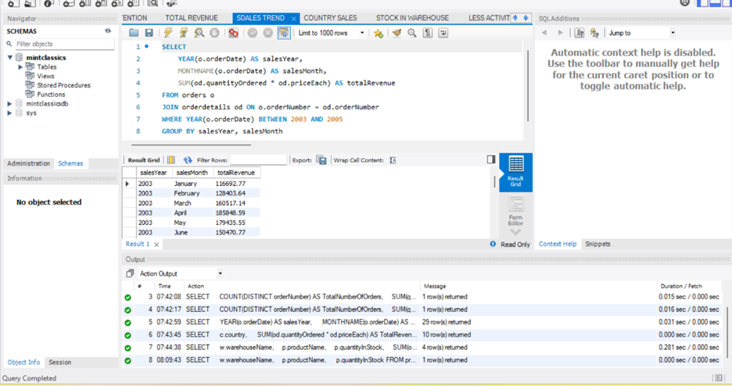
ANALYSIS 8: CREDIT LIMIT
The SQL query was used to analyze and understand customers’ credit limits. If credit limits are not properly regulated, they can negatively impact the company’s revenue. In this analysis, customers’ credit limits were limited to 10 for visualization.

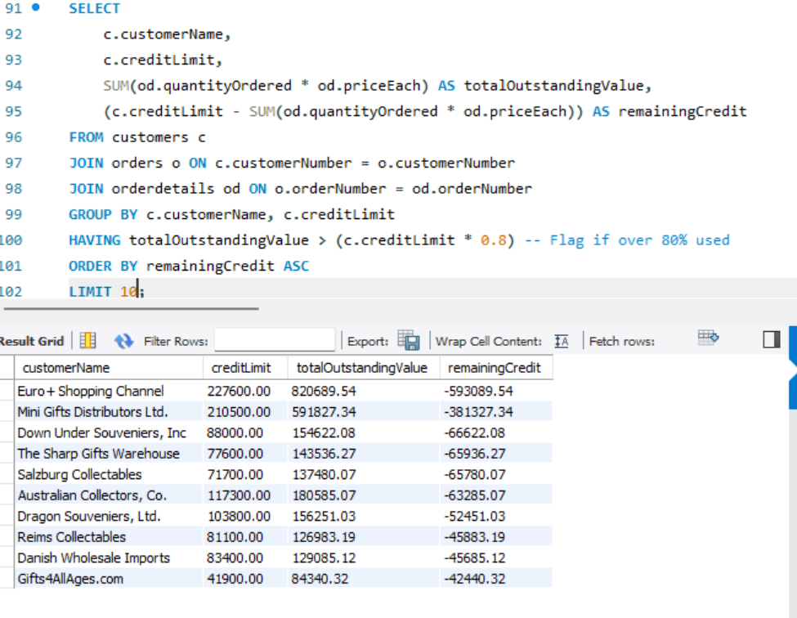
INSIGHTS:
For more detailed insights, the transformed SQL results were exported into a dashboard, as visual representation provides a clearer understanding of complex data. This dashboard offers a simplified yet comprehensive view of the overall project through KPIs and charts, including revenue, warehouse stock levels, highest product demand, sales representative performance and country with the highest sales.
Despite these achievements, the company is experiencing a downward trend, which is more clearly highlighted in the dashboard and easier for stakeholders, especially non-technical users, to interpret.
From the visualization, it was observed that sales generally declined around 2005. While SQL queries alone could not fully reveal these insights, the dashboard made it possible to identify that the company is carrying a high level of uncollected credit risk. The downward trend in the line chart likely reflects the impact of an unsustainable credit strategy, which is affecting the company’s ability to maintain consistent revenue growth.
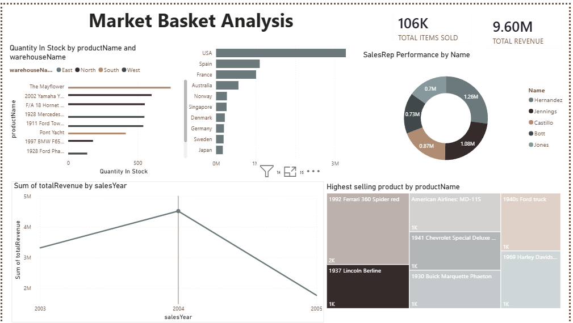

RECOMMENDATION
Establish Automated Credit Controls: Implementing a rule-based workflows that automatically flag or block orders for accounts exceeding their credit thresholds. This prevents further exposure until accounts are reviewed.
Continuous Portfolio Monitoring: Move beyond static credit limits by monitoring real-time risk signals, such as payment delays or changes in financial health, to proactively manage your credit portfolio.

